CSE 3461

Lab Report II

Professor: Chunyi Peng

Jiasong (Jason) Sun (200275947), Manlan (Lynn) Li (200301962)

1. Abstract

This project requires us to implement UDP as well as reliable data transfer protocol (RDT 3.0) to perform the data transfer. Code in both sender side and receiver side are implemented.

1. Description

   2. Process
2. Difficulties
3. User Manual
   1. Compile:
      1. In your own Linux OS, open a terminal
      2. In the project folder, type *make* in the terminal, this should call Makefile, which is already included in the lab1 directory and **server** executable file will be generated;
      3. Type *cd receiver* enter receiver folder, type *make*. This should call Makefile again, which is already included in the lab1 directory and **client** executable file will be generated;
   2. Run:
      1. On your terminal, Type *./server port# 0.2*

(port# can be any arbitrary number outside the range of 0~1024)

* + 1. Open another terminal, in your receiver folder type *./client localhost port#* ***testFile*** *0.2* testFile can be one of these three types: .html .jpeg (.jpg) .gif

1. Sample Output
   1. Sender side

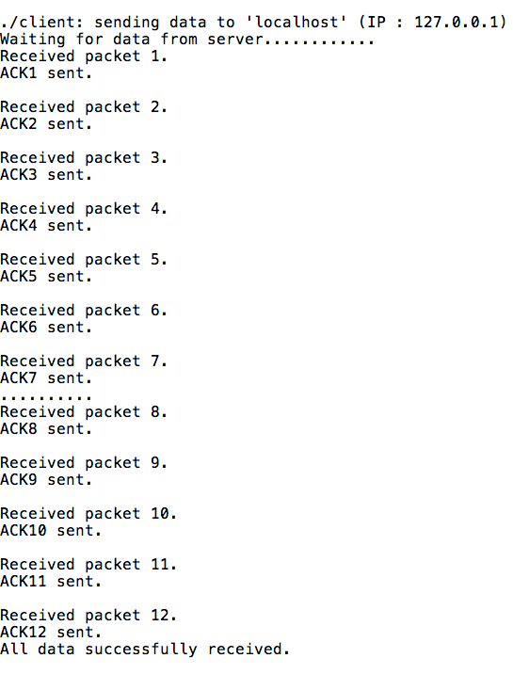

* 1. Receiver Side

